 | CSCI/ISAT B104  Computer Programming Techniques, Practices, and Tools  Spring 2026  Project Documentation  Team 5

Contents
Project Contributions by Team Member 2
Collaboration Tools 3
YRBS Questions Explored 4
YRBS Demographic Information Explored 5
YRBS Data Winnowing & Retrieval 6
Research Question and/or Hypothesis 7
Bibliography 8
Acknowledgements 8

Project Contributions by Team Member

Members and their Contact Information
Member | Email | Text
Daniel DiCesare | dicesard@uscb.edu | 631-305-6157
Brandon Cruz | Bc81@email.uscb.edu | 703-501-5485

Overall
Relative Contribution of each member over the course of the entire project

Member | Contribution | Total Hours
Daniel DiCesare |  | 1

YRBS Question Identification & Documentation
Member | Contribution | Hours | Components

YRBS Data Winnowing & Retrieval
Member | Contribution | Hours | Components

Data Analysis (via Python)
Member | Contribution | Hours | Components

Data Visualization (via Python)
Member | Contribution | Hours | Components

GUI Creation (via Python)
Member | Contribution | Hours | Components

Python Script Creation
Member | Contribution | Hours | Components

Presentation Preparation & Practice
Member | Contribution | Hours | Components

Project Documentation & Administration
Member | Contribution | Hours | Components

Collaboration Tools
Tools to assist with task management, version control, communication, etc.

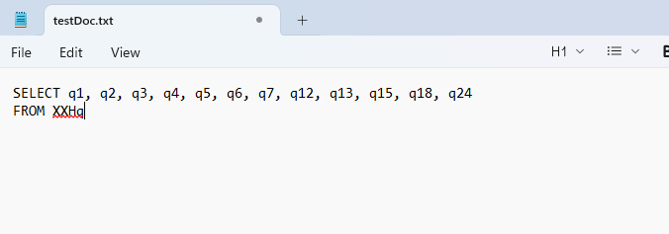

Take data from “2023_National_YRBS_Data_Users_Guide508.pdf”

Update the questions to just be q1, q2, q3, q4, q5, q6, q7, q12, q13, q15, q18, q24
Create SQL query
Convert it to Microsoft excel
Save as excel file.

Used chatgpt to get a spyder file to be able to read data from our excel file.
Spyder file is “FinalProject.py” Excel file is “B104_Project_Data2.xlsx”. This google doc is “B104_Team_XX_ProjectDoc(1).docx”. Github repository for storing this stuff is “B104_QueryData”

Questions we want to answer are the relationship between: Age, sex, grade, Hispanic/Latino status, Race, weight(lbs), height(ft) VS.
How many days of 30 did students bring a weapon to school, during the past 12 months how many days did students carry a gun, during the past 12 months how many times were students threatened with a weapon, if students had ever seen someone get attacked in their neighborhood, during the past 12 months have students been bullied on school property.

TO DO: get specific questions we want answered, for example relationship between age + weight to gun carrying + gun violence or something like that.
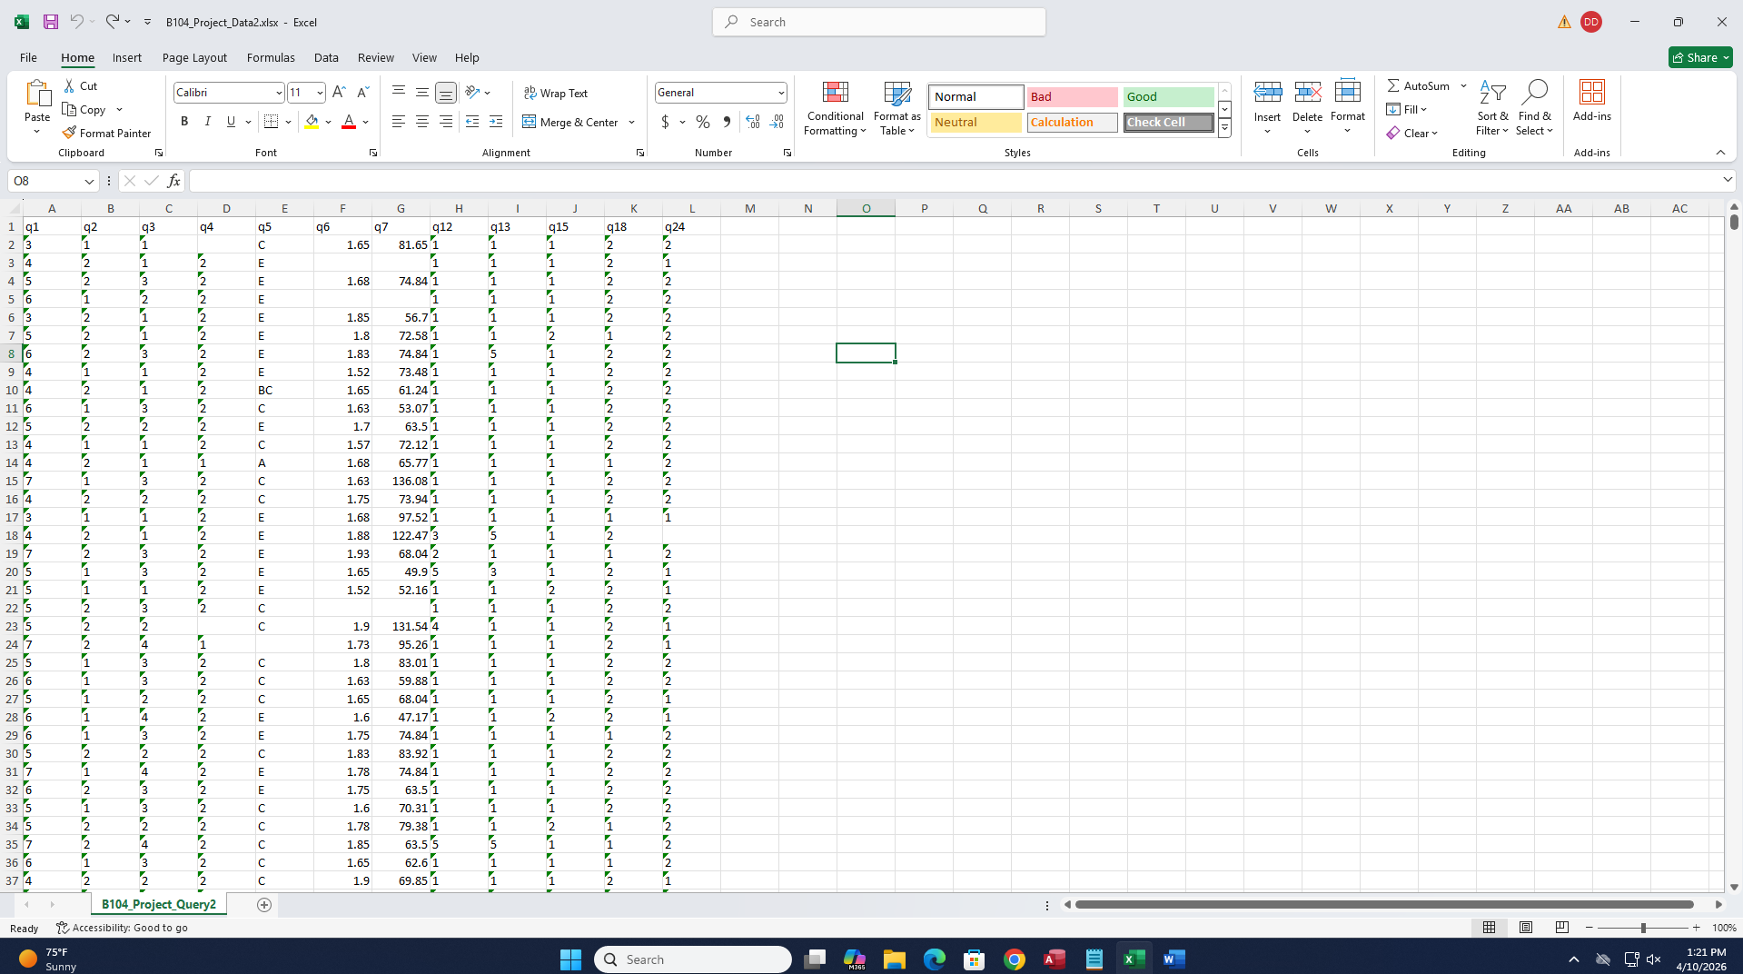

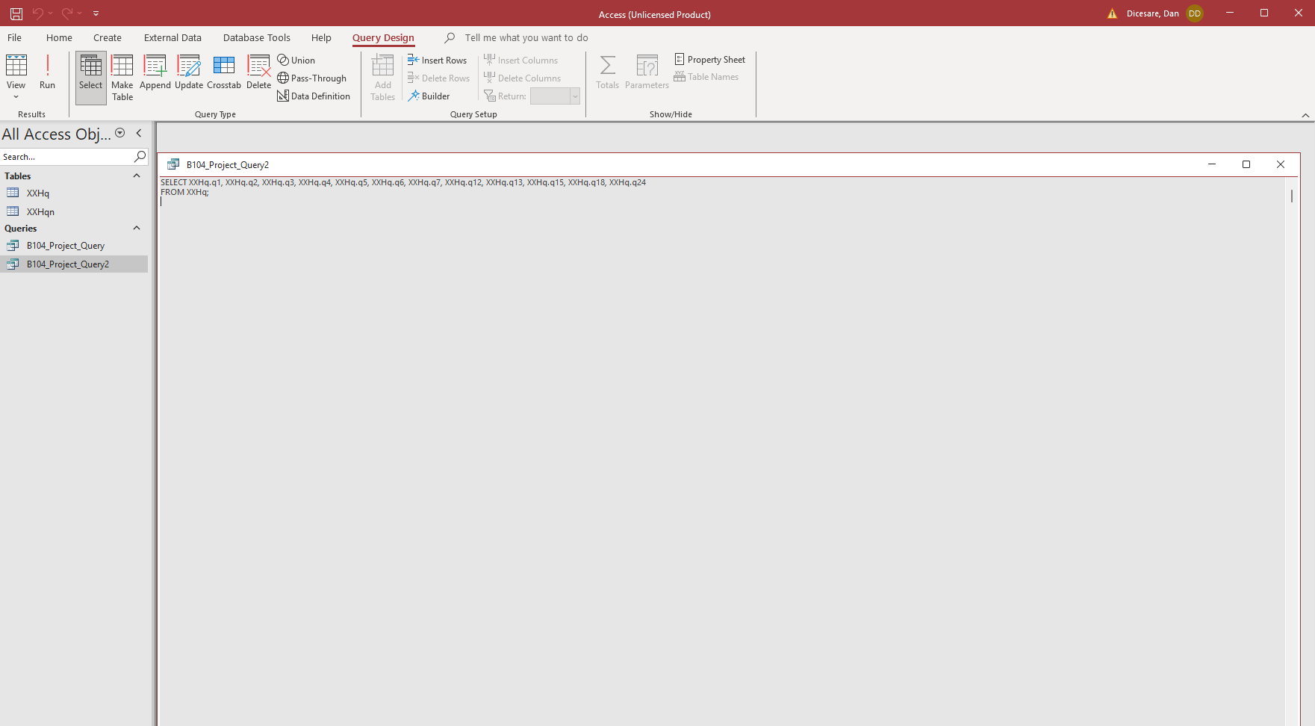

YRBS Questions Explored
Questions & responses explored over the course of the project.

Place screenshots of the two questions below. Be sure to include their “response keys”.

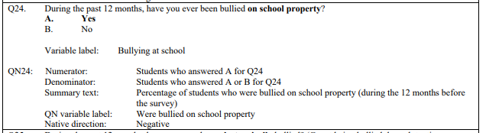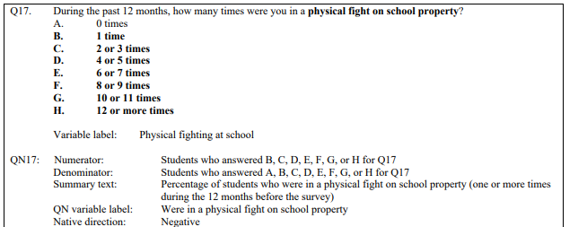

YRBS Demographic Information Explored
Demographic questions & responses explored over the course of the project

Place screenshots of the questions below. Be sure to include their “response keys”.

Demographic information includes gender, age, height, weight, ethnicity, etc.

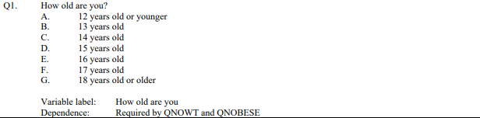

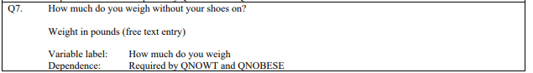

YRBS Data Winnowing & Retrieval
How we winnowed & retrieved the data explored over the course of the project.

Write down a step-by-step guide explaining how you winnowed & retrieved the data from the YRBS site.

Place screenshots of the SQL code and other relevant details here

Research Question and/or Hypothesis
The specific research questions we sought to answer.

Write down your research question here.

Bibliography
Resources which we used over the course of the project.

Citations for:

Python Library Documentation
Python Tutorials
Best Practices
Poster Templates
Stack Overflow questions/answers
Etc.

Follow APA format

Acknowledgements

Specific peers who helped you debug
Upper class students, parents, siblings, friends, etc. who provided feedback and guidance
Etc.

